**PROJECT**

**HEALTHCARE DATA INSIGHTS**

**Name:** Harish Kumar Sahu

**Name of Project:** Health Care Data Insights

**Summary:**

* I analyzed a dataset of **55,000 US patients**, which included details like **Patient Name**, **Age**, **Gender**, **Blood Group**, and **Medical Conditions**, etc. Using **SQL** scripts, I gained a deeper understanding of the **healthcare patterns** within the data.
* The **list of tasks** I performed can be essential for **The Hospital's Chief medical director and the managers** to get insights about a particular health issue or a particular age group that is suffering from a common medical condition.

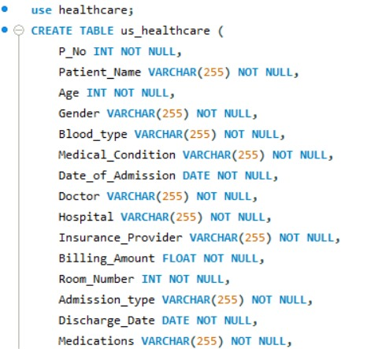

1. How many stayed in the hospital for less than 7 days? Did the majority stay in the hospital for less than seven days?

1. How many types of health problems are there, and what was the most common among them?

1. How many patients received care under each hospital, and which medical hospitals have a count of more than 35 patients?

1. Which Insurance Provider has the max patients enrolled under them and which insurance providers has more than 10000 patients.

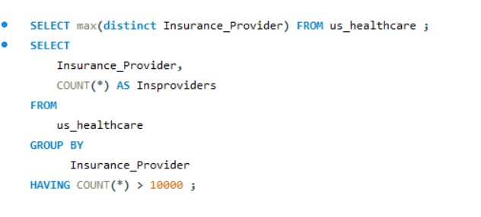

1. Which doctor treated the most number of patients?

1. Was there any correlation between medical condition and the number of days in hospital stay?

1. Find different type of medications provided and order by most used.

1. Which patients came into the hospital with an emergency) and stayed for less than the average time and give a total count in the end?

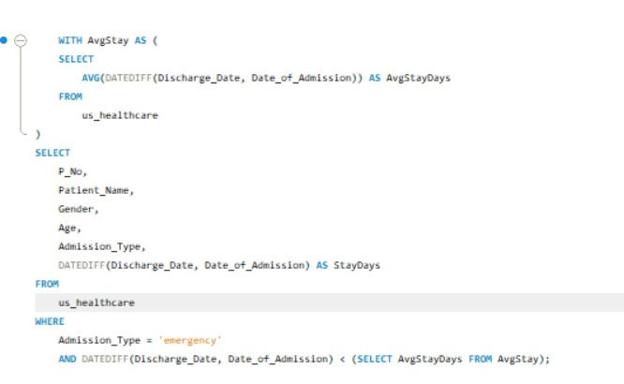

1. Categorize different age groups of patients along with their gender in a single query.

1. List billing amount 1 to 10000 as low,10001 to 40000 as middling and above 40000 as high and give the count of people.

1. Categorize patients based on blood group and distribute no of patients.

